Lesson 4: Layout elements and web page design

About the lesson
This lesson introduces students to the structure of HTML documents and the use of semantic elements to define different sections of a web page. They will learn how to define the width of an element and add a border and padding to adjust the layout on the page. They will apply this learning to practical activities using the HTML and CSS files provided.
Learning objectives
By the end of this lesson, students will be able to:
- set up an HTML web page correctly
- use sematic elements to define different parts of a web page
- adjust the styling to control the layout and appearance of a web page.
National Curriculum
The following subject content from the KS3 National Curriculum is included in this lesson:
- Use two or more programming languages, at least one of which is textual, to solve a variety of computational problems
- Undertake creative projects that involve selecting, using, and combining multiple applications, preferably across a range of devices, to achieve challenging goals, and meeting the needs of known users
- Create, reuse, revise and repurpose digital artefacts for a given audience, with attention to trustworthiness, design, and usability
Links
Websites are integral to modern life and link to every area of the curriculum and beyond.
Key terminology
semantic elements, border, padding
Teaching and learning activities
Share the objectives for the lesson with students (Slide 2 of Lesson 4 presentation).
Starter
Ask students to complete Activity 4.1: Parts of a web page (Interactive 4.1, Slide 3).
Part 1
Explain the layout of an HTML document (Slides 4–7 and page 158).
Ask: What does the <head> element of a web page contain?
Information about the web page, including its title and a link to its style sheet.
Ask: What does the <body> element of a web page contain?
The actual text and other content to be displayed on the screen.
Explain that the different parts of the <body> element can be defined using semantic elements (Slides 8–10 and page 158, plus Video 4.1).
Explain how the width of an element can be defined so that it only fills a certain proportion of the screen (Slide 11 and page 159).
Ask students to complete Activity 4.2: Setting the width and layout of elements (Slide 12/page 159/Worksheet 4.2, plus lesson4_index.html, lesson4_style.css and birthdayCake.png).
- Check that 'lesson4_index.html', 'lesson4_style.css' and 'birthdayCake.png' have all been saved to the same folder on students' computers.
- Students should only be editing 'lesson4_style.css'; they should not be editing 'lesson4_index.html'.
Answers
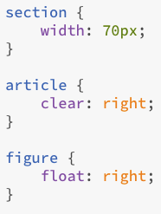
When displayed in a browser the web page should look something like this:
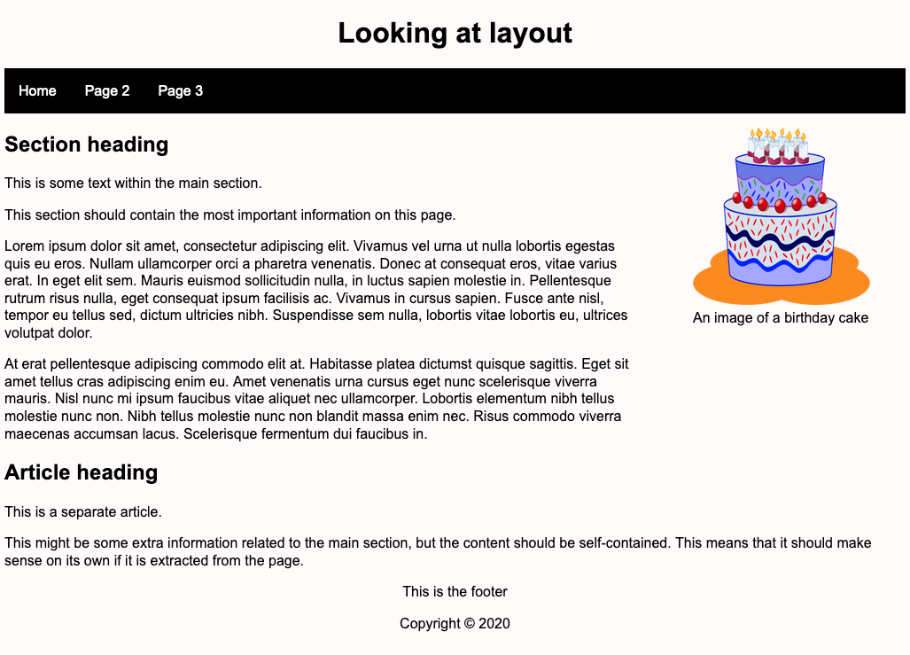
Explain how to add a border and padding to an element (Slides 13–14 and page 159, plus Video 4.2).
Ask students to complete Activity 4.3: Adding borders and padding (Slide 15/page 159/Worksheet 4.3, plus lesson4_index.html, lesson4_style.css and birthdayCake.png).
- Students should only be editing 'lesson4_style.css'; they should not be editing 'lesson4_index.html'.
Answers
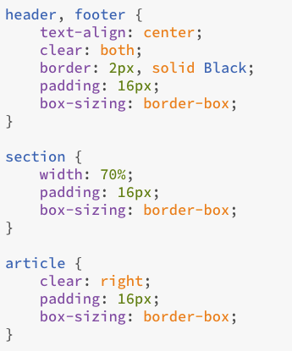
When displayed in a browser the page should look something like this:
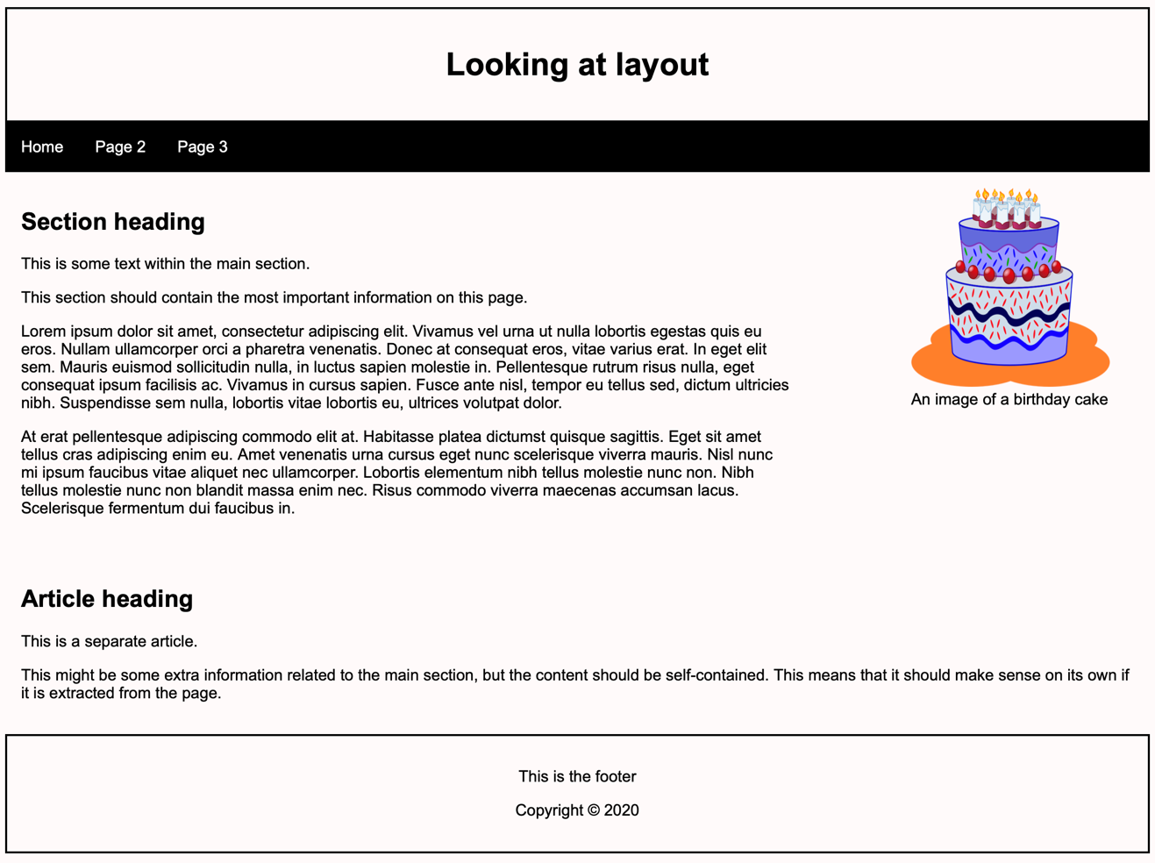
Part 2
Ask students to complete Activity 4.4: Personalising the styling (Slide 16, pages 158–159/Worksheet 4.4, plus lesson4_index.html, lesson4_style.css and birthdayCake.png).
- Students should be encouraged to try out their own colour combinations and fonts to gain an appreciation of the way in which their choices affect the readability and aesthetics of a web page.
Example answers
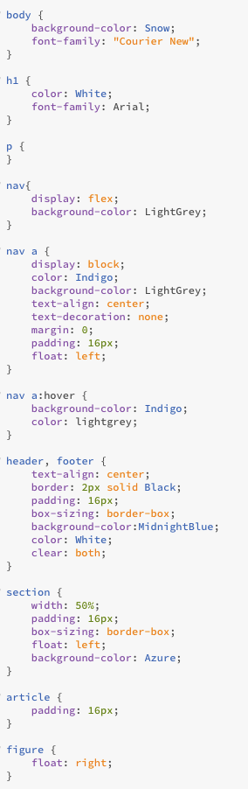
- The values will vary because students are choosing their own fonts and colours, but the code on the right produces the example web page on the worksheet.

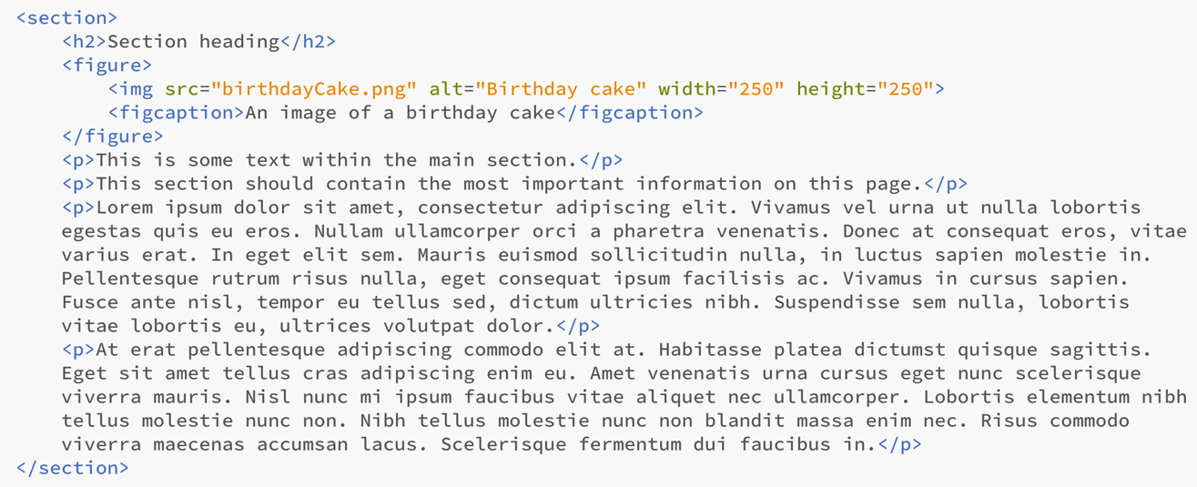

Plenary
Check students' knowledge and understanding with a short question and answer session linked to the learning objectives for the lesson.
- What must the first line of an HTML document contain?
(Answer: <!DOCTYPE html>)
- Why does an HTML document need to include this line of code?
(Example answer: So that the browser knows that it is an HTML5 document, and it is displayed correctly.)
- What is the top section of an HTML document called?
(Answer: the <head> element)
- What is the bottom section of an HTML document called?
(Example answer: the <body> element)
- Name three different semantic elements?
(Answer: any three from: <header>, <footer>, <section>, <article>, <nav> and <figure>)
Homework
Ask students to complete any activities they did not finish during the lesson.
Ask students to complete Quiz 4 (Slide 17).
Stretch activities
Students who complete the activities in this lesson quickly could be encouraged to investigate more advanced CSS styling features, such as rounded corners, backgrounds and colour gradients. Information can be found at https://www.w3schools.com/css/default.asp, and selecting from the options under CSS Advanced from the listings on the left-hand side of the screen.

Support activities
Support students on an individual basis as required and encourage them to use the ‘Key Points for Students’ document as a reference to help with the syntax required. Some pupils may benefit from working in pairs to support each other as they work through the activities. Remind students that each CSS property is followed by a colon, and then the value that is needed, followed by a semi-colon. Setting out each property on a new line helps to make the text easy to read and to spot errors such as missing punctuation.
Additional explanations on the styling covered in this lesson can be found at https://www.w3schools.com/html/default.asp and selecting appropriate item from the side-bar menu or using the search facility.

